7. Dynamic Design

1. Sequence Diagram

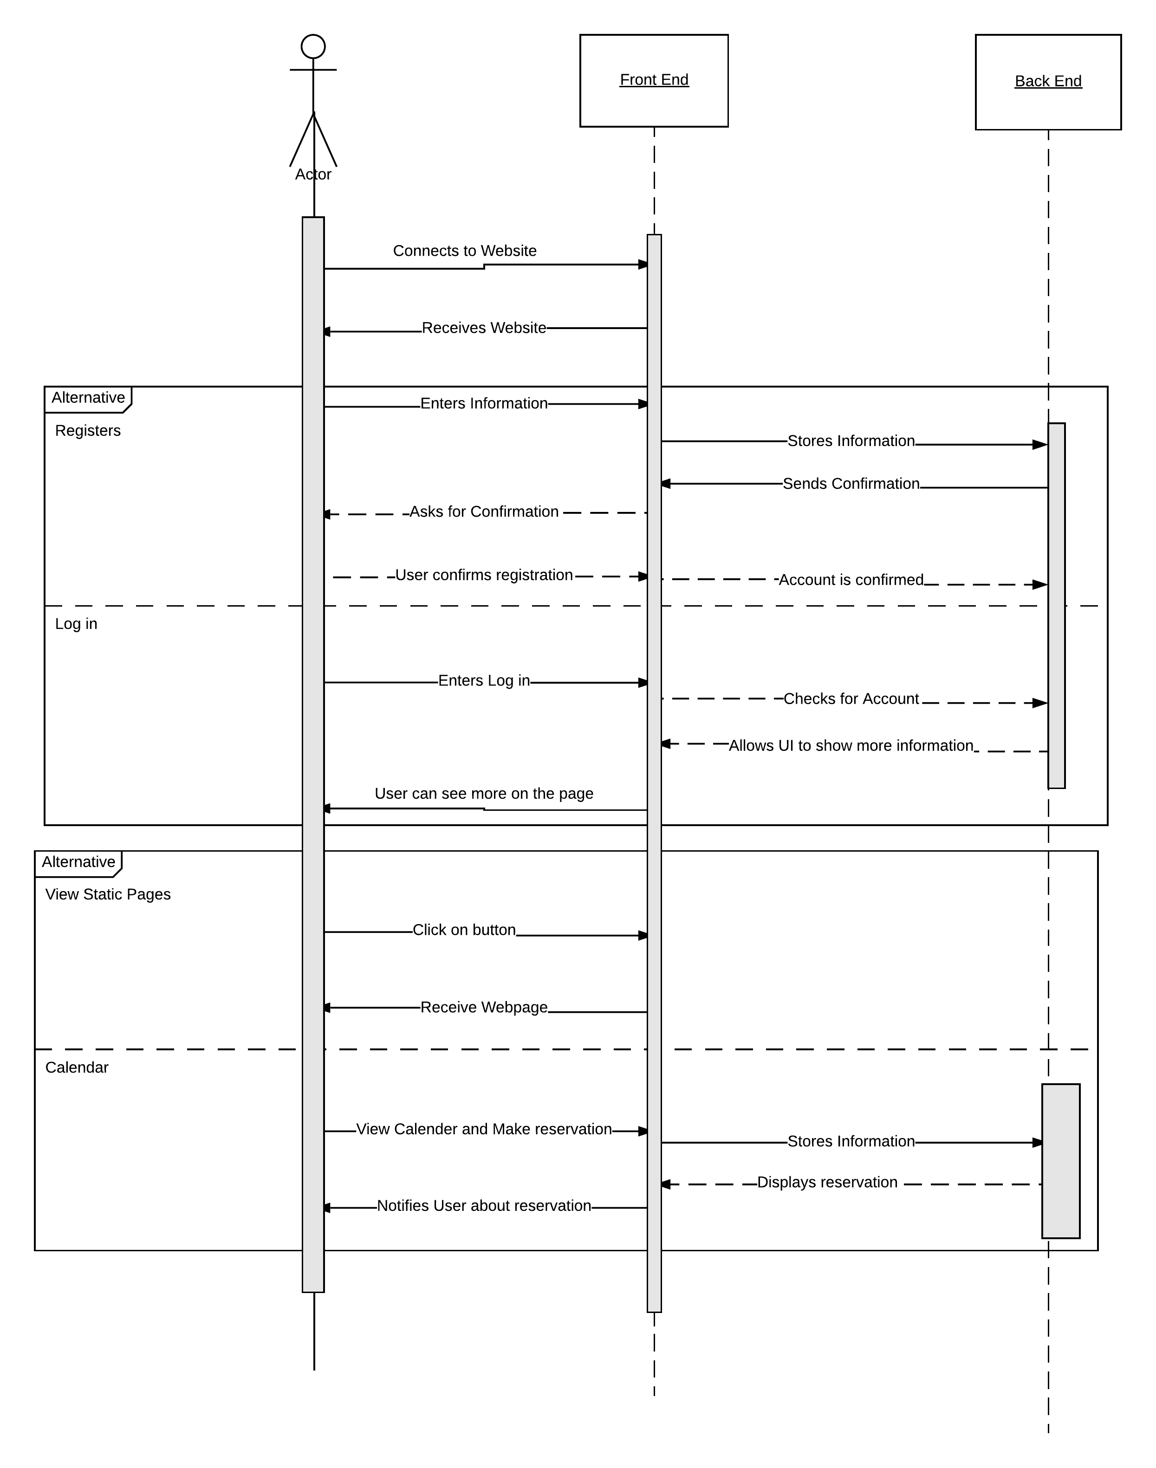

1. Interface Specification
2. State Diagrams
   1. Viewing Static webpages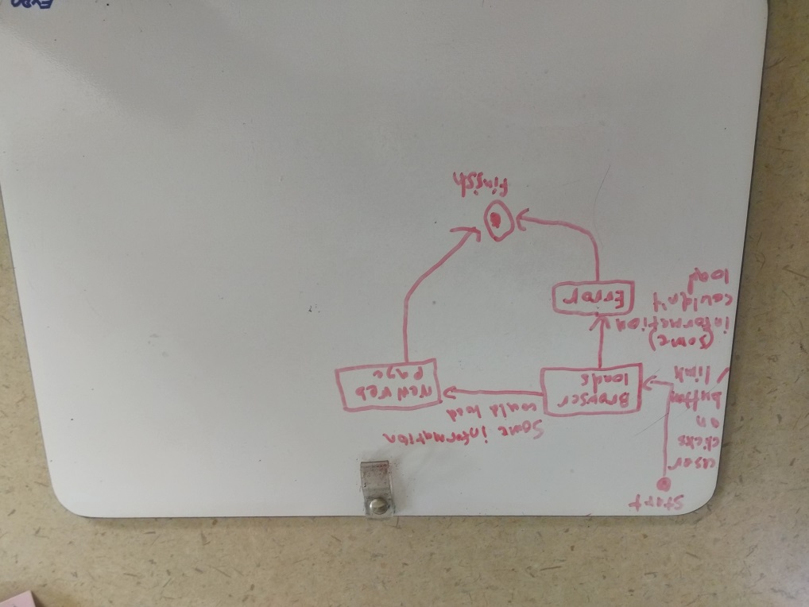
   2. Viewing Current Reservations on Calendar

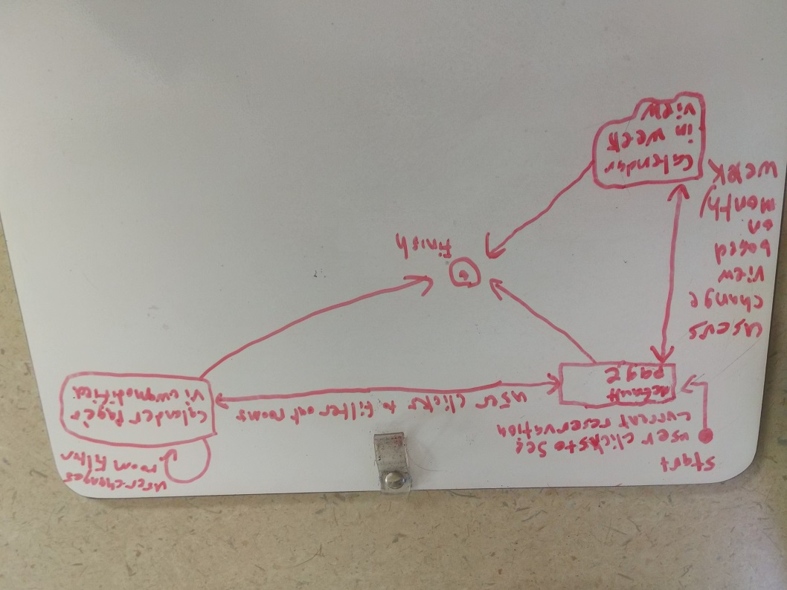

* 1. Users Creating New Reservations

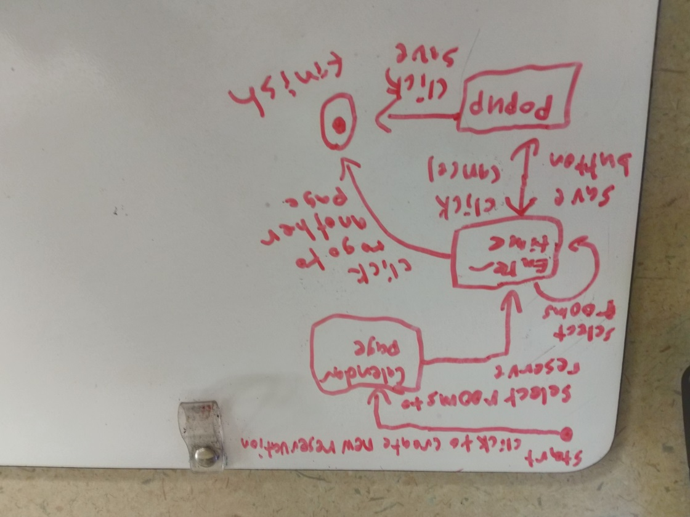

* 1. Admins Approving/Disapproving Reservations

